**Android Application: Conductor’s Panel**

**Prerequisite:**

* The database should already be available.
* At least one Route with minimum two stops should be added.

**Setup:**

* Install and Setup Android Studio
* Open this Project in Android Studio
* In MainActivity.java, replace the IP Address and Port number on Line 51 with the IP and Port Number of the Server.
* Connect an NFC-Enabled Device (with active internet connection) to your Computer with a data cable.
* Click on the Available Devices drop-down from the Menu Bar and select the name of the Device.
* Run the Project.
* Once the App opens on the device, check that it works perfectly like in the screenshots given below.
* Stop the execution by either closing the App on the Device or stop the execution from Android Studio.
* The App has now been downloaded on your Device.

**Note:** Being an Android Application, the look and feel of the application changes based on the device. However, as long as the device supports NFC and has an active internet connection, the actual working of the program remains the same.

**Screenshots:**

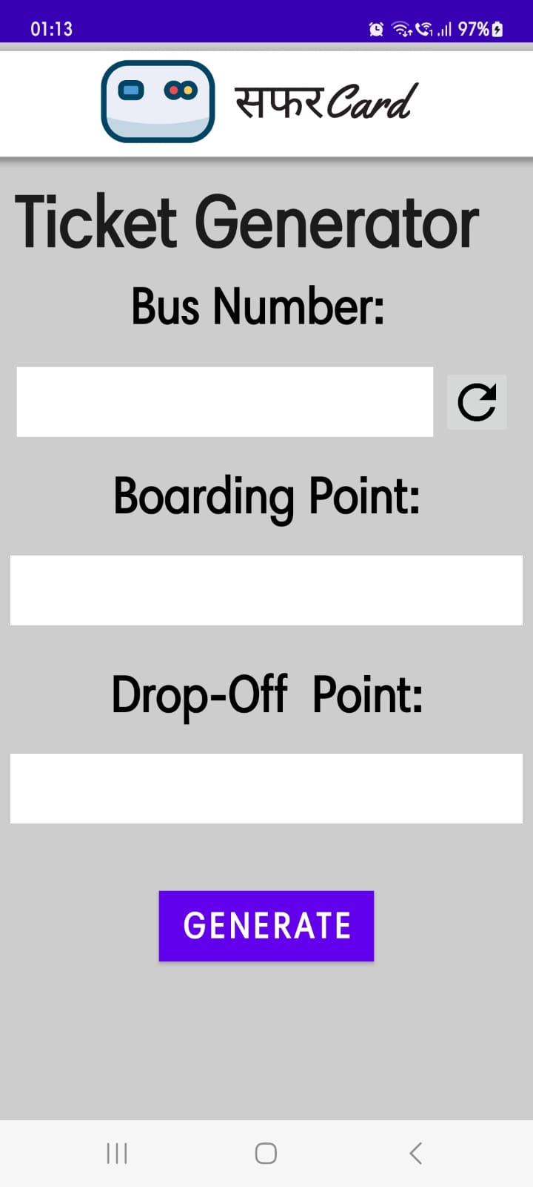

*Fig. Dashboard*

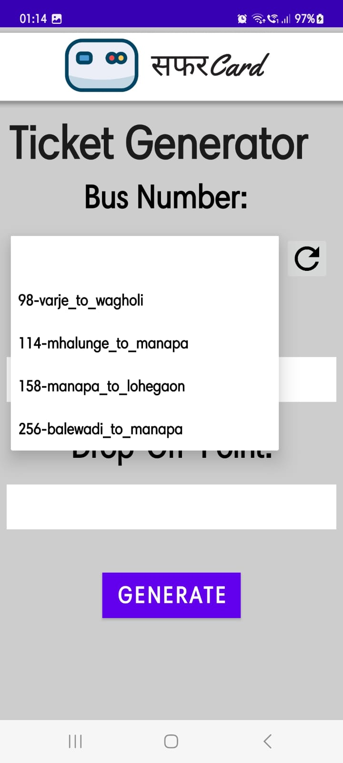

*Fig. Fetching Routes from Database*

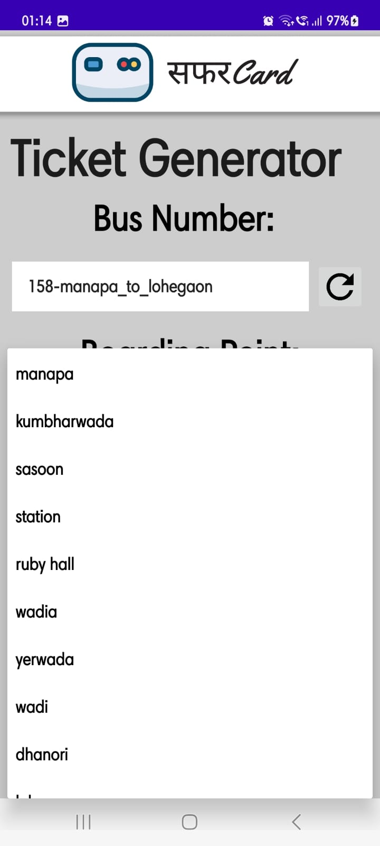

*Fig. Fetching Stops from Selected Route*

*Fig. Selecting Boarding and Drop-Off Point*

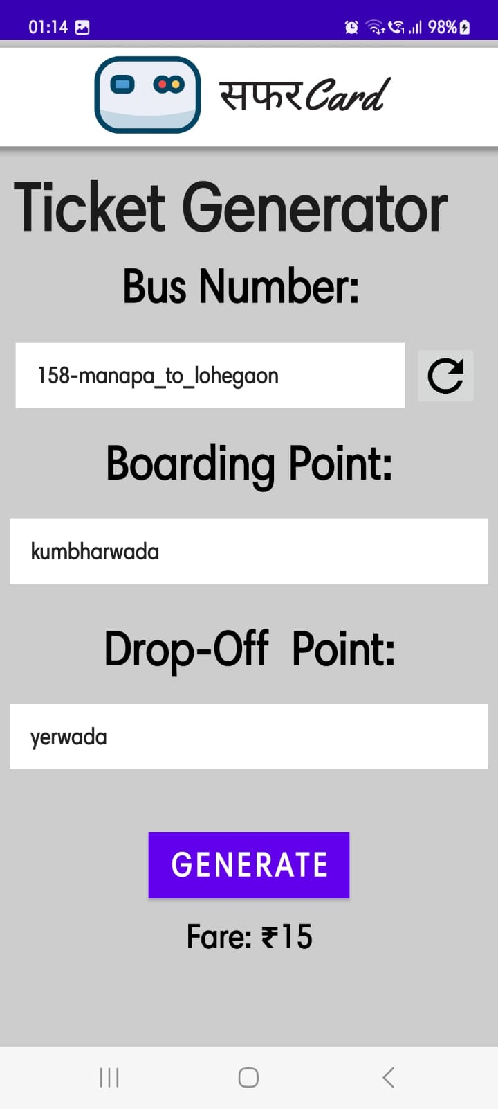

*Fig. Generating Ticket*

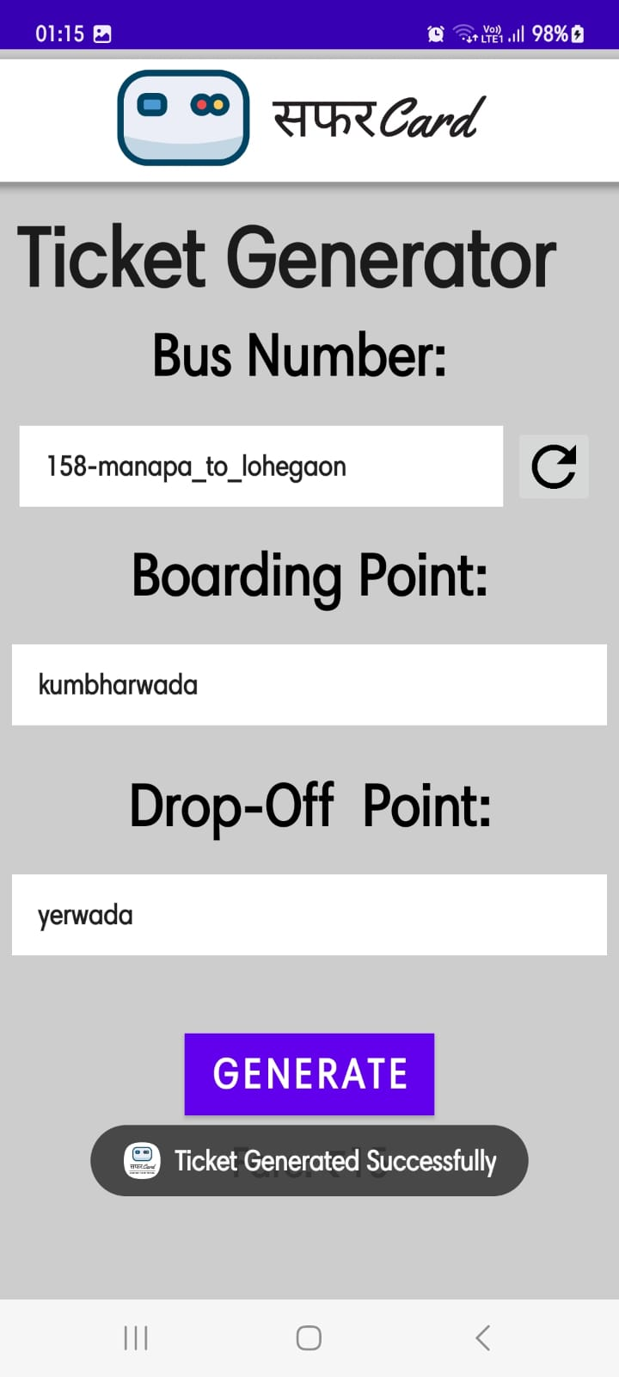

*Fig. Deducting Fare*

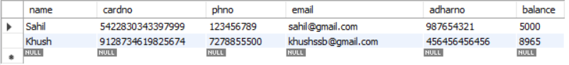

*Fig. Before*

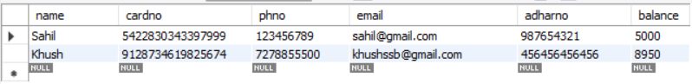

*Fig. After*